PYTHON - MINI PROJECT

PROJECT TITLE: DISASTER TWEET DETECTION

Group 1 –

Ritesh Bhalerao - 05

Arin Choudhary - 11

Atharva Khanvilkar – 33

Under the Guidance of Mrs. Lifna C.S

DESCRIPTION –

The ubiquitousness of smartphones enables people to announce an emergency they’re observing in real-time. Because of this, more agencies are interested in programmatically monitoring Twitter (i.e., disaster relief organizations and news agencies).But it’s not always clear whether a person’s words are announcing a disaster.

Our project builds a machine learning model that predicts which tweets are about a real disaster and which tweets are not.

Program Flow - 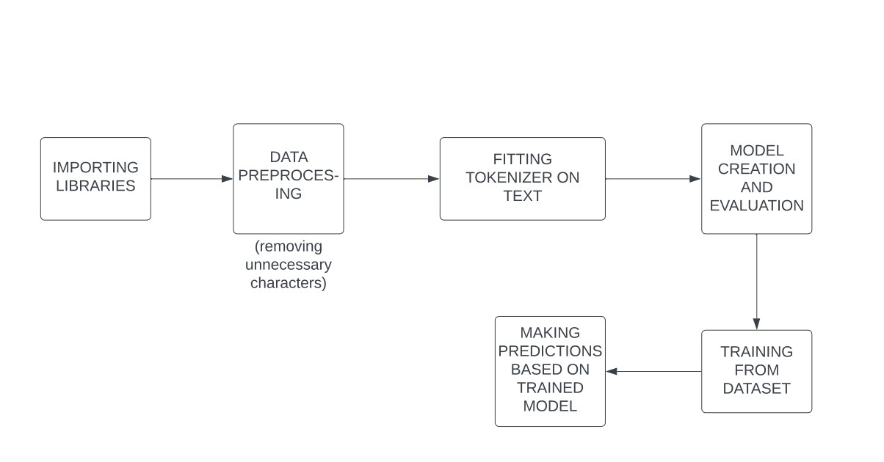

PROGRAM -

https://github.com/K-Atharva01/Python-MP.git

OUTPUT:

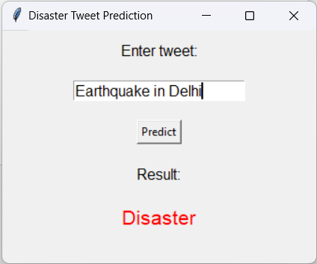

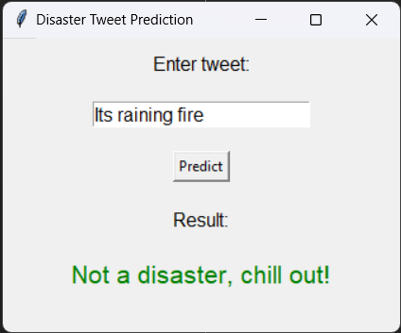

CONCLUSION -

FINDINGS:

1) Social media is a valuable source of information during disasters: Social media platforms like Twitter are increasingly used by people to report incidents during disasters, and this information can be used to improve disaster response.

2)Automated classification of disaster tweets is feasible: Researchers have found that machine learning models can effectively classify tweets related to disasters and can even outperform humans in some cases.

3) Features like hashtags and mentions can improve classification performance: Researchers have found that including features like hashtags and mentions in addition to the text of the tweet can improve classification performance

APPLICATIONS:

1. Improving disaster response: By analyzing tweets related to disasters in real-time, disaster response teams can get a better understanding of the situation on the ground and respond more effectively.
2. Providing situational awareness: Disaster tweet classification can help provide situational awareness to emergency managers and decision-makers, allowing them to make more informed decisions about resource allocation and response efforts.
3. Predicting and detecting disasters: By analyzing social media data, it may be possible to detect early warning signs of disasters, allowing for early warning and preparation.
4. Monitoring and tracking the spread of misinformation: During disasters, there is often a lot of misinformation and rumors that spread on social media. Disaster tweet classification can help track the spread of this misinformation and allow emergency managers to respond appropriately.
5. Improving communication with the public: By understanding what people are saying on social media during disasters, emergency managers can tailor their communication strategies to better reach and inform the public.